# Computer Vision Hw8 Report

* Discription
  + Noise Removal
* Algorithm
  + Box filter (3x3, 5x5)
  + Median filter (3x3, 5x5)
  + Opening then Closing
* Parameters (if any)
  + no
* Principal Code Fragment

Main (file – /src/hw8/ DemoNoiseRemoval.java)

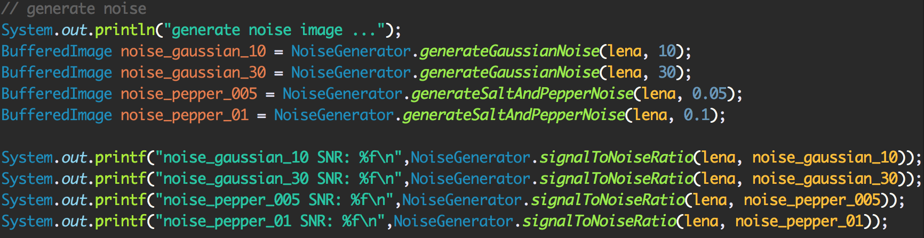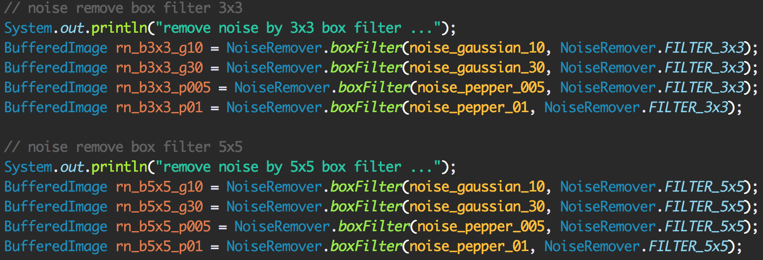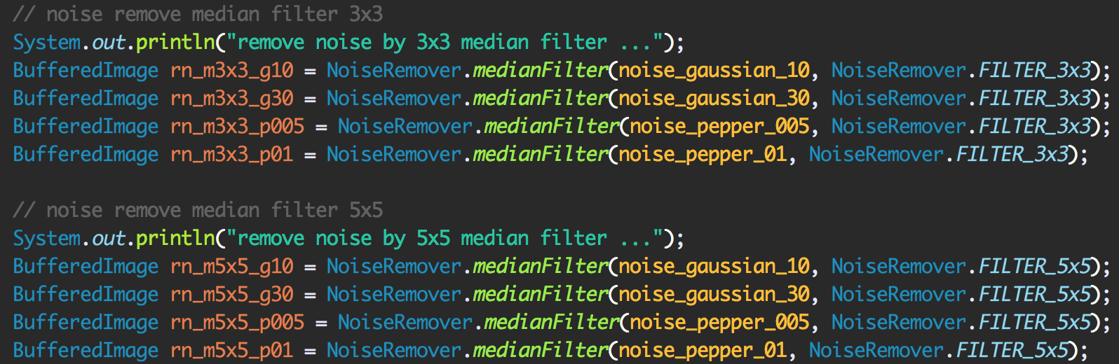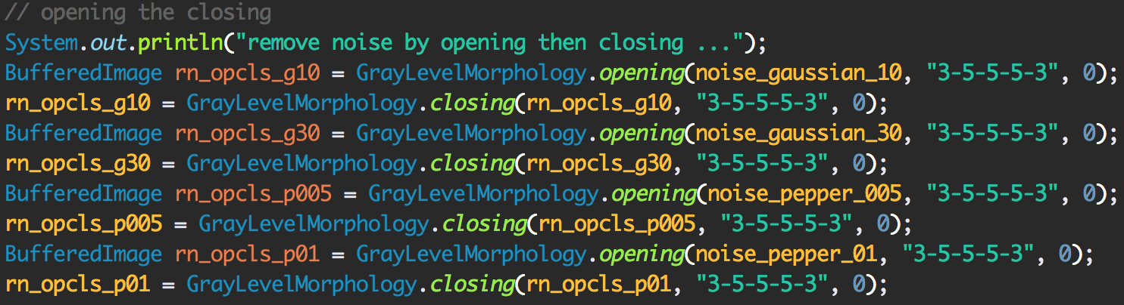

NoiseGenerator

(file – /src/cv1.util.cv.noise /NoiseGenerator.java)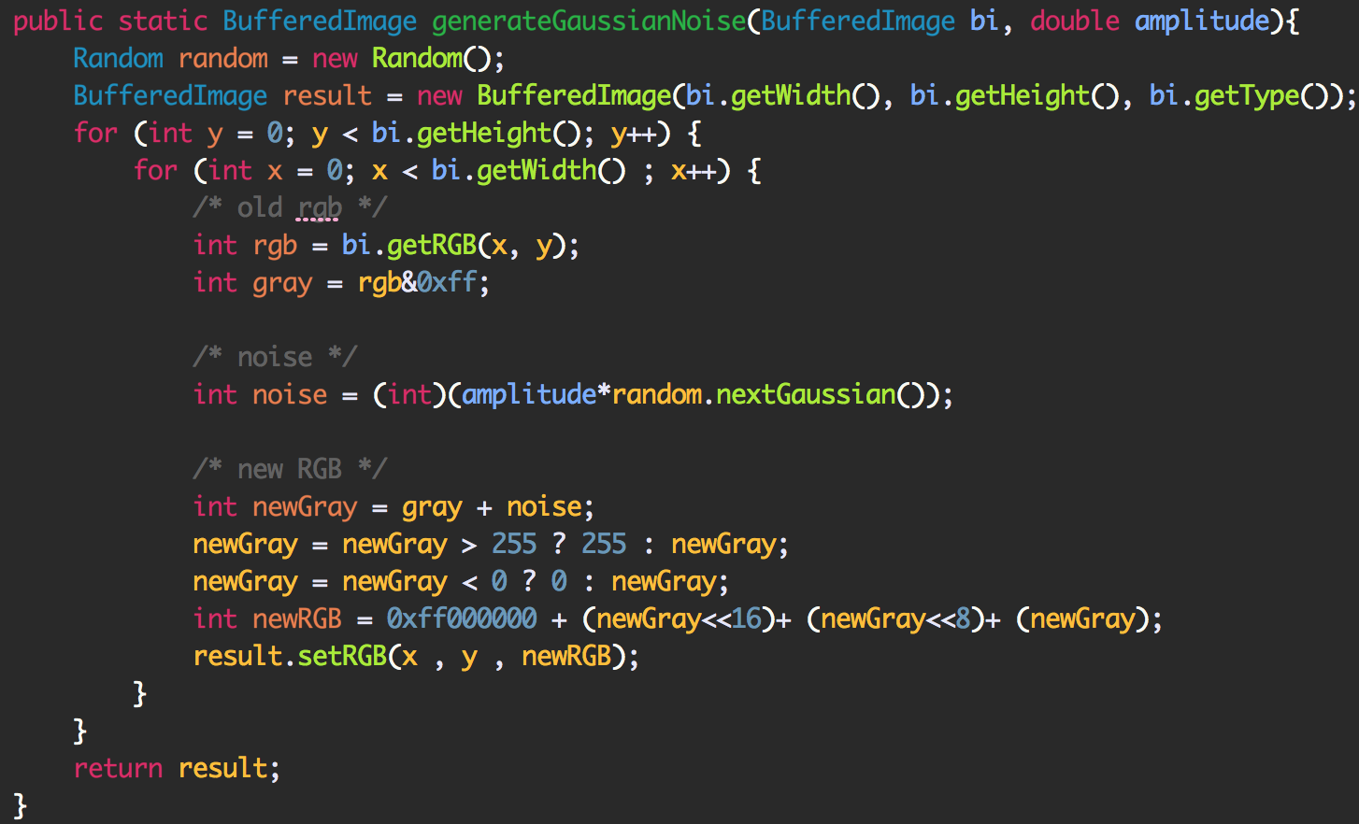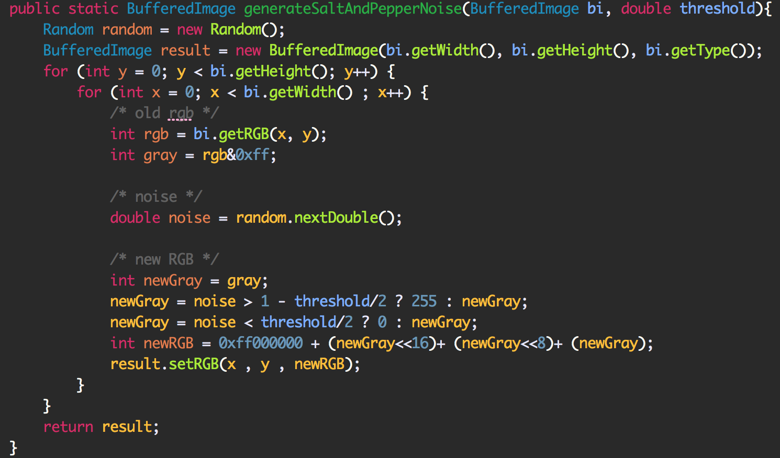

NoiseRemover

(file – /src/cv1.util.cv.noise /NoiseRemover.java)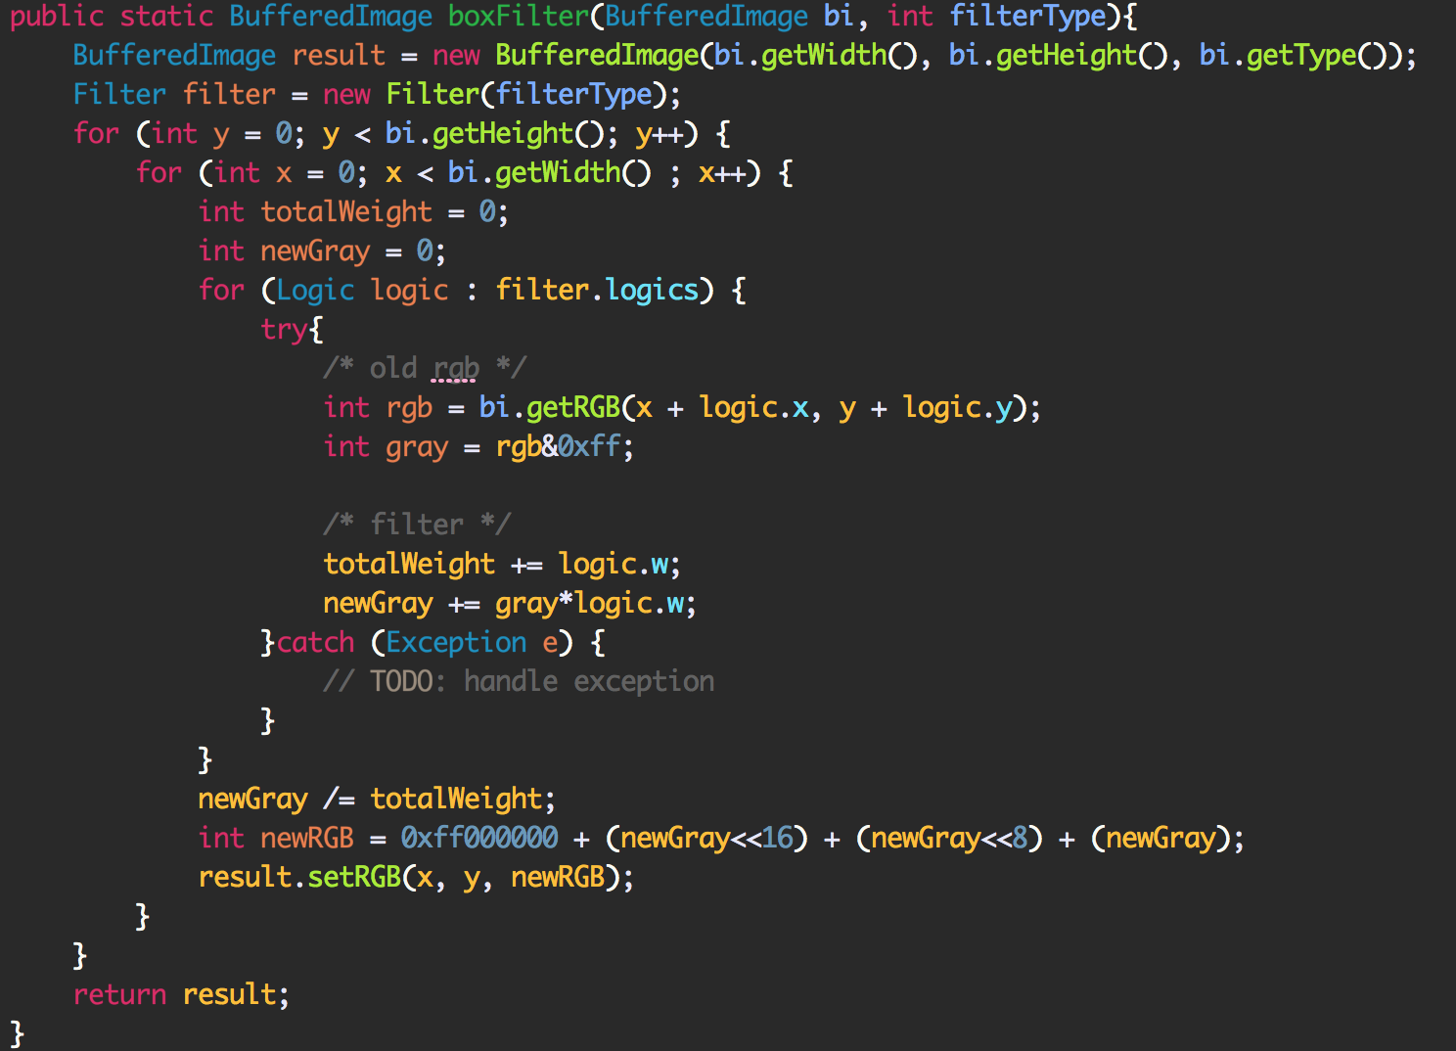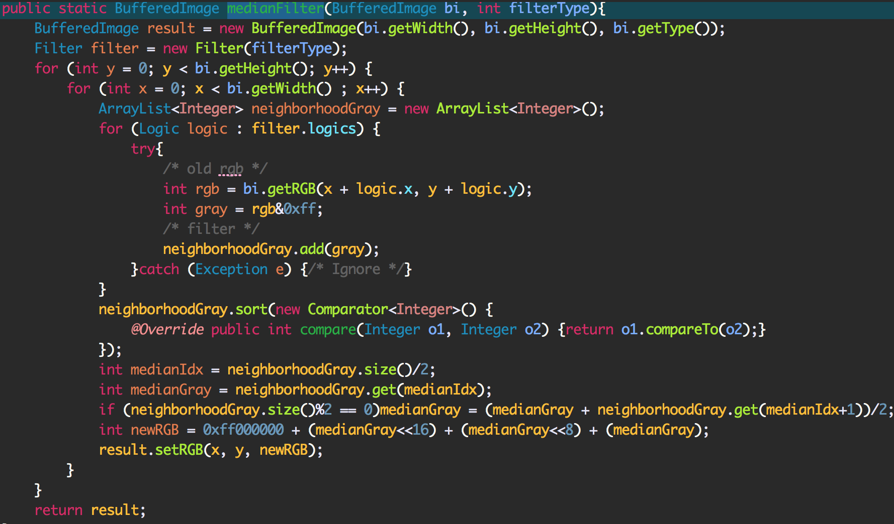

* Result Image

Noise (Gaussian-10, Gaussian-30, S&P-0.05, S&P-0.1)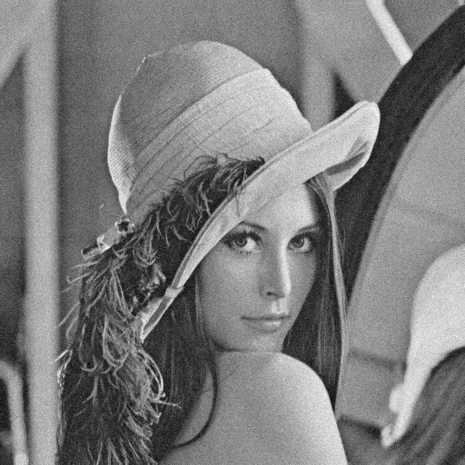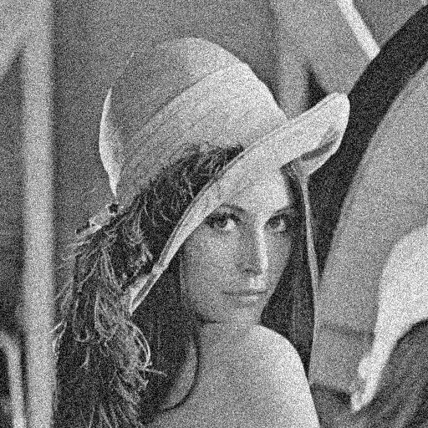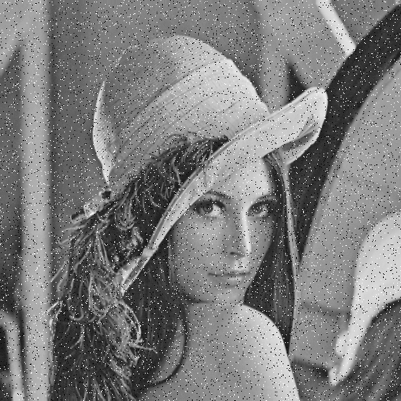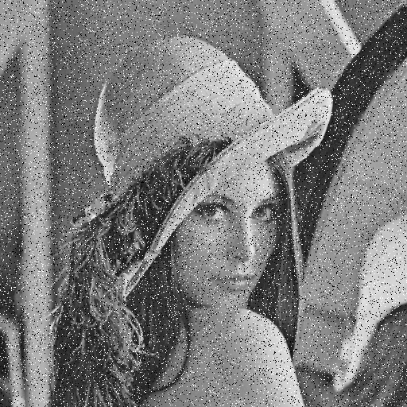

SNR (Gaussian-10, Gaussian-30, S&P-0.05, S&P-0.1)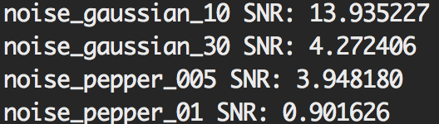

3x3 Box (Gaussian-10, Gaussian-30, S&P-0.05, S&P-0.1)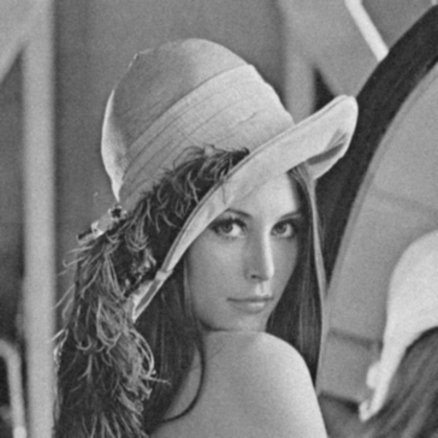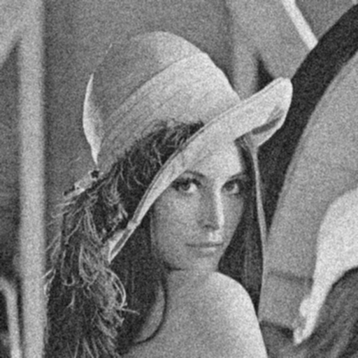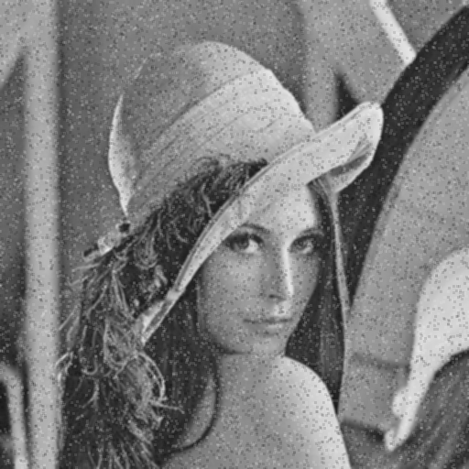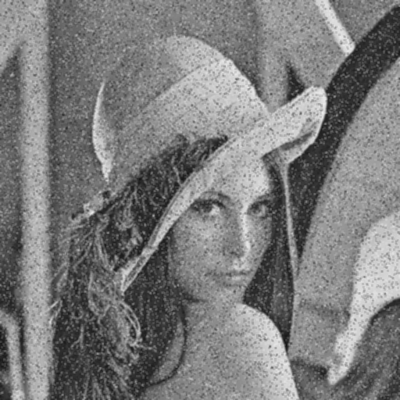

SNR (Gaussian-10, Gaussian-30, S&P-0.05, S&P-0.1)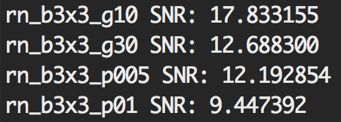

5x5 Box (Gaussian-10, Gaussian-30, S&P-0.05, S&P-0.1)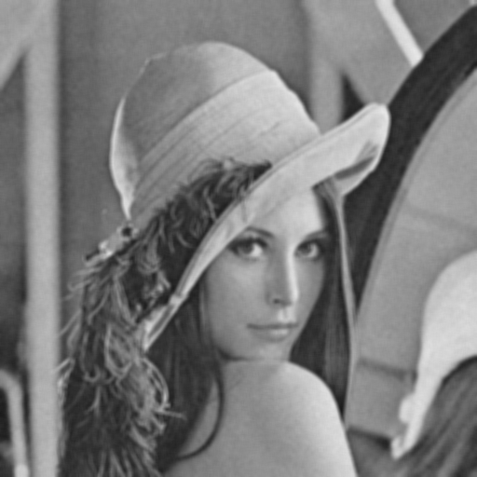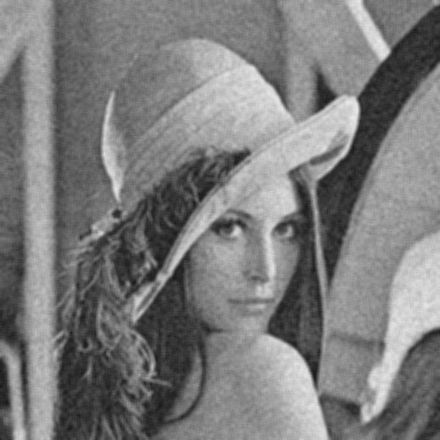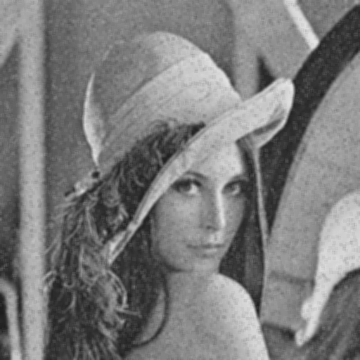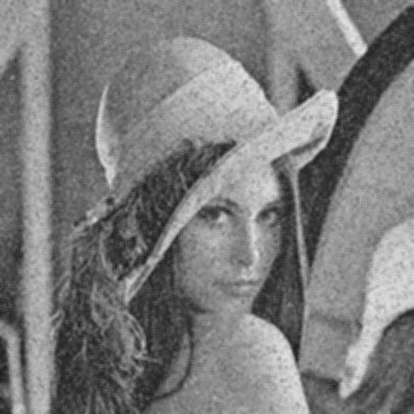 SNR (Gaussian-10, Gaussian-30, S&P-0.05, S&P-0.1)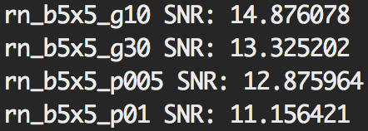

3x3 Median (Gaussian-10, Gaussian-30, S&P-0.05, S&P-0.1)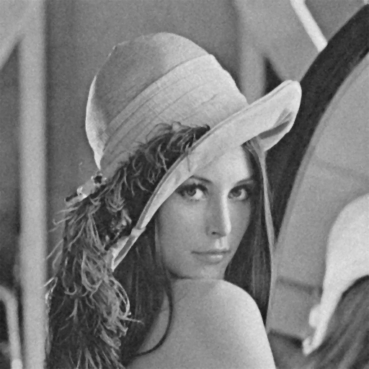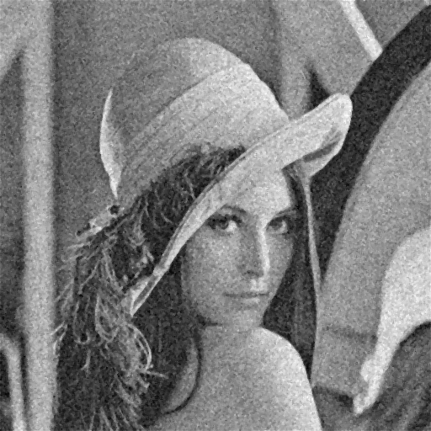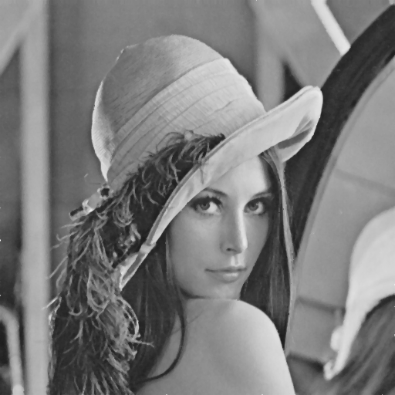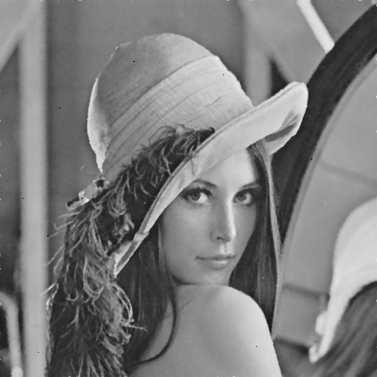 SNR (Gaussian-10, Gaussian-30, S&P-0.05, S&P-0.1)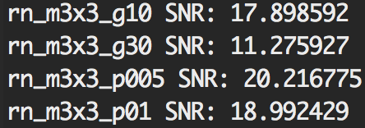

5x5 Median (Gaussian-10, Gaussian-30, S&P-0.05, S&P-0.1)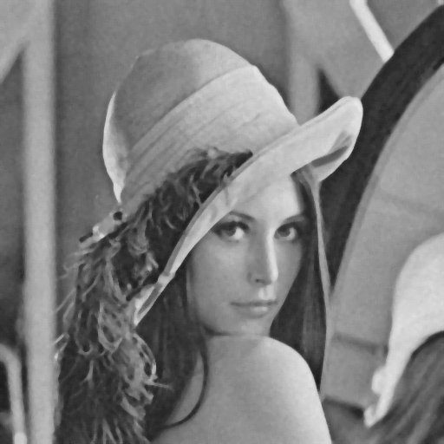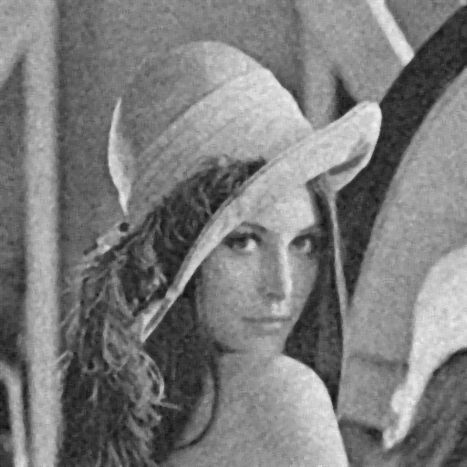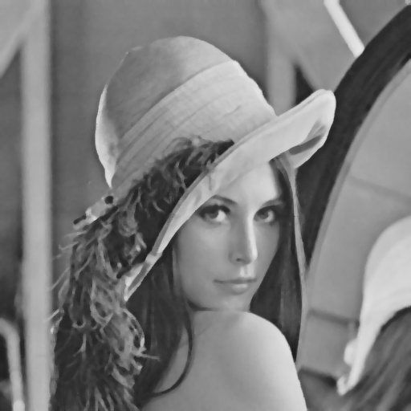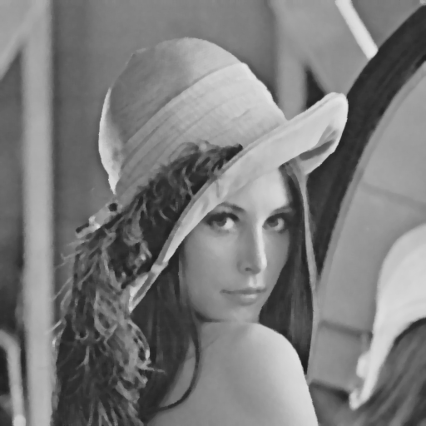 SNR (Gaussian-10, Gaussian-30, S&P-0.05, S&P-0.1)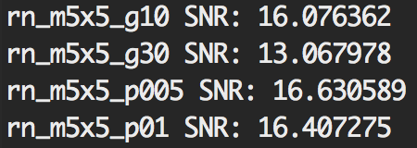

Open-Closing (Gaussian-10, Gaussian-30, S&P-0.05, S&P-0.1)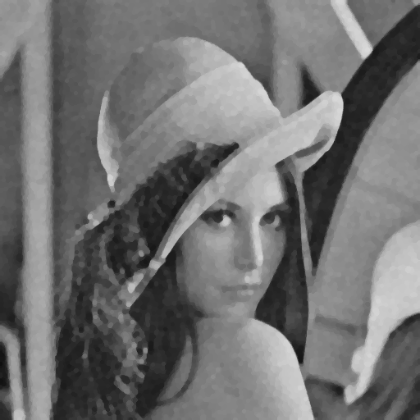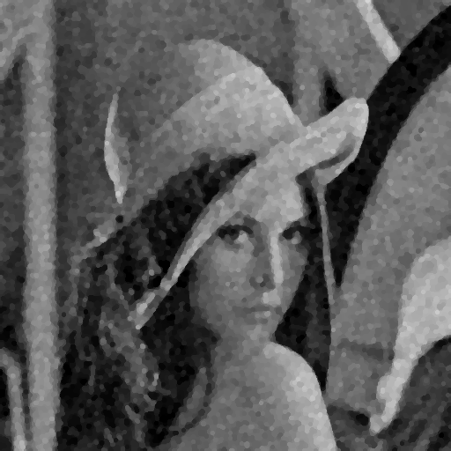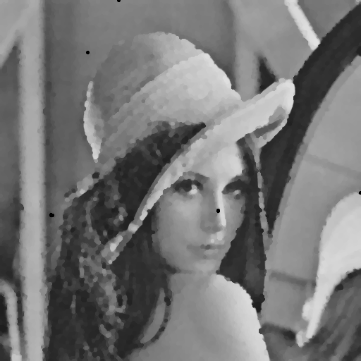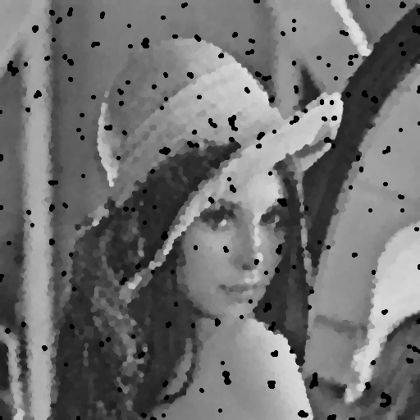 SNR (Gaussian-10, Gaussian-30, S&P-0.05, S&P-0.1)